Project 1: Hive - Incremental Data Load

Author : Devendra Kumar Rajendran

-------------------------------------------------------------------------------------------------------------------------------

**Database : incr_load**

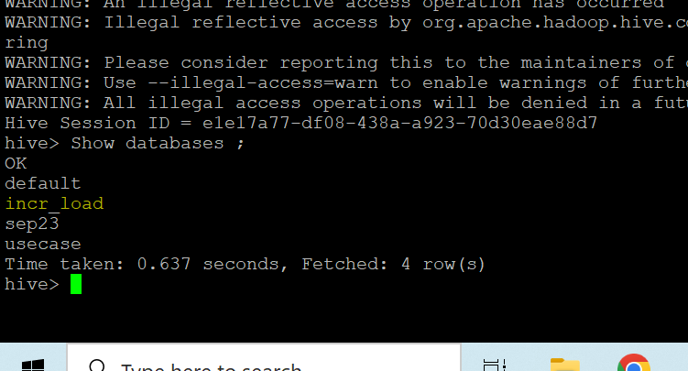

**Tables :**

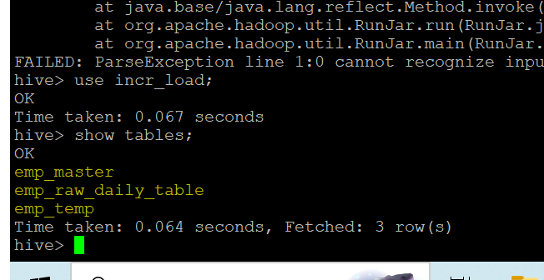

**Shell Script & HQL Files Path :**

**Location path: /home/Dell/bin**

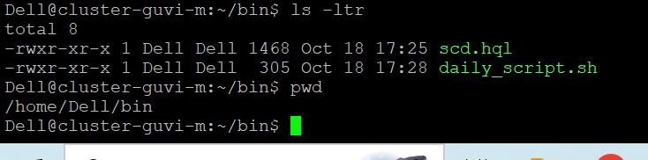

**Files Path :**

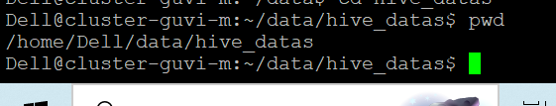

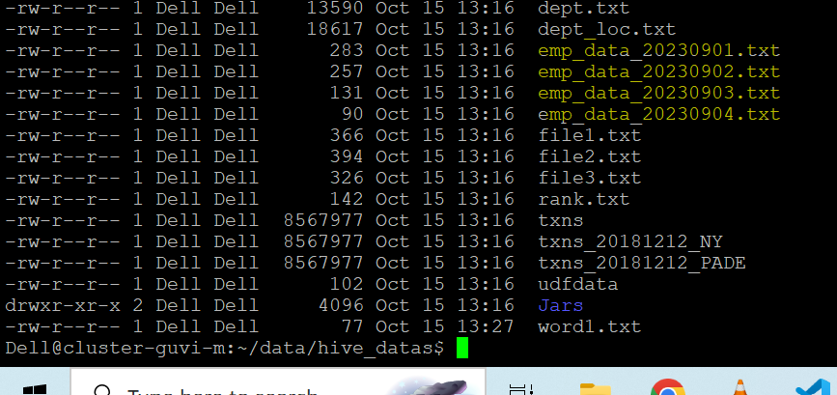

**Results :**

**Day 1 : File Uploaded**

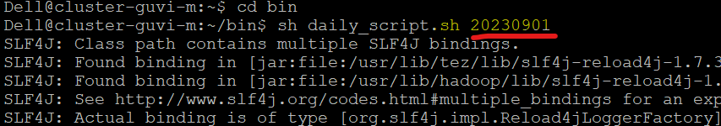

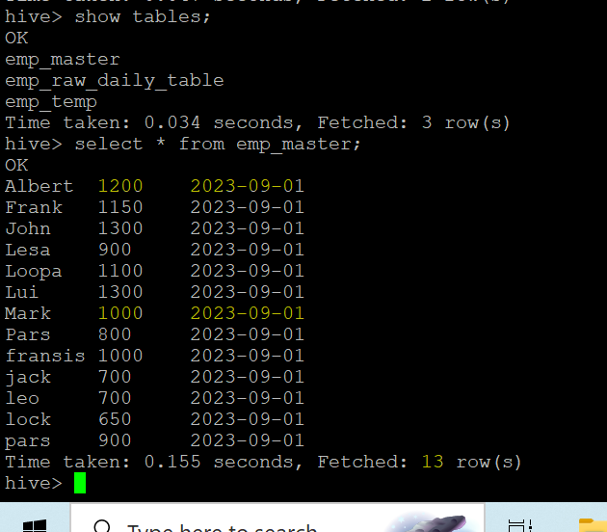

**Day 2 : File Uploaded**

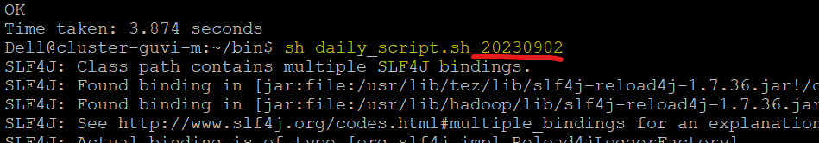

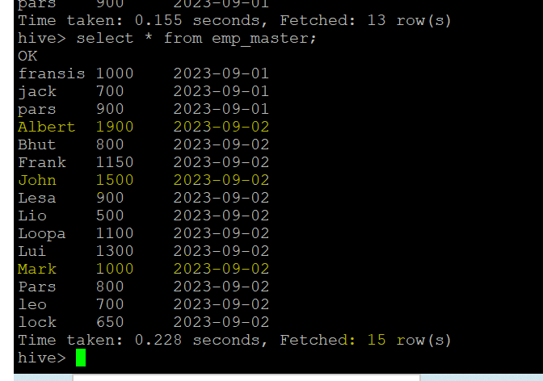

* Albert & John wages got updated with auto increment with data loaded and date is 2023-09-02 .
* Mark wages are same and data has got updated with date 2023-09-02.

--------------------------------------------------------------------------------------------------------------------------------